嘉義縣忠和國民中學
110學年度雙語國家政策－口說英語展能樂學計畫
子計畫2-1：國民中小學英語日活動成果報告表
活動名稱 | Speak English and Shoot |  | 辦理日期 | 110.12.30
辦理地點 | 學習扶助教室 |  | 參加人數 | 全校學生
成果摘要-活動內容介紹及特色說明  (列點說明) | 英文活動將會結合國際教育、多元文化議題來進行闖關活動。  過關條件:全程使用英文才可以過關。  English Speak and Shoot!  1. Get in line. (and be quiet)  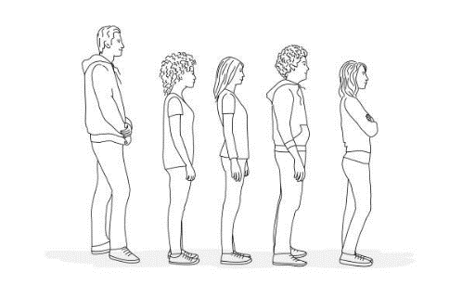  2. Before it is your turn, use some hand sanitizer.  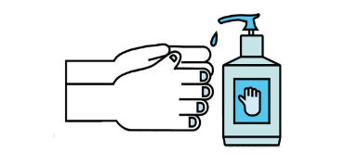  3. Come to Table 1 when the teacher calls, “Next” come up to the front to pick a question from the ‘Jong-Ho Lucky Question Box’.  4. Read the question into the microphone.  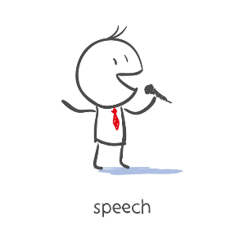  5. You have 30 seconds to answer your question.  If Paul says” yes”, you make it. Move on!  If Paul says” no”, you fail and leave.  6. When you are finished, put the question in the “Used Questions’ box.  7. After you have answered the question walk to Table 2 and take 2 shots with the Nerf gun.  If you hit one of the cups on the table (blackboard?) across from you, you win a prize.  8. After shooting the gun, take your group card to get stamped even if you do not win a prize.  9. Leave for the next game!
檢討或建議事項 | - 此次闖關活動是結合本校多元文化周活動一併進行。  - 將社團教室布置成為闖關區，比較能夠讓孩子融入英語情境。  - 從發想點子、規劃到執行計畫，均是所有英語老師戮力同心的結果。
照片說明（4-10張）
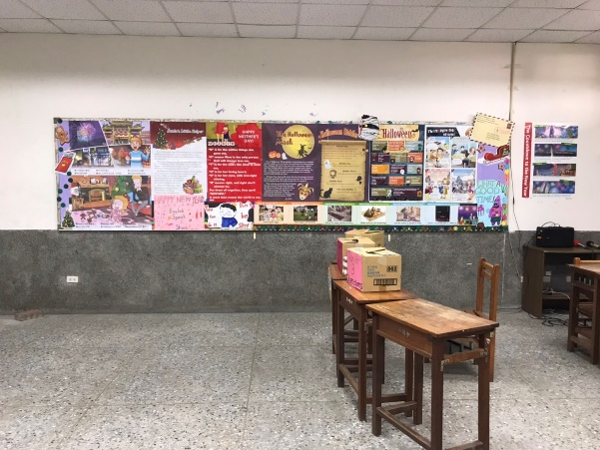 |  | 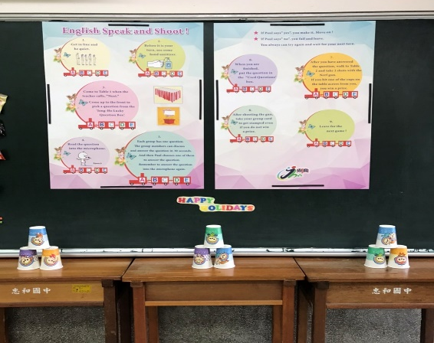
先布置英語闖關教室(創造情境) |  | 先布置英語闖關教室(創造情境)
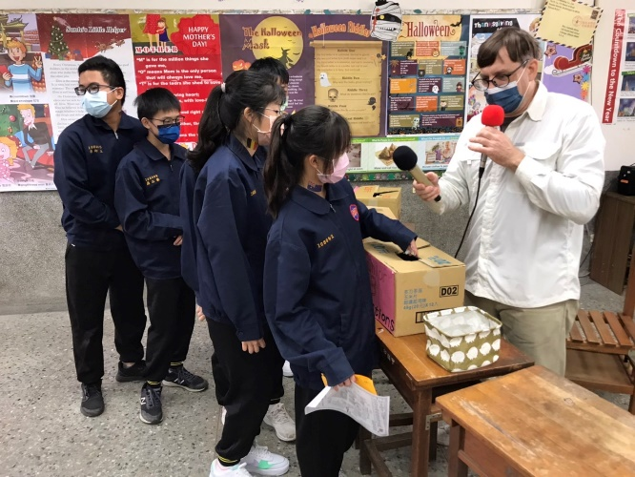 |  | 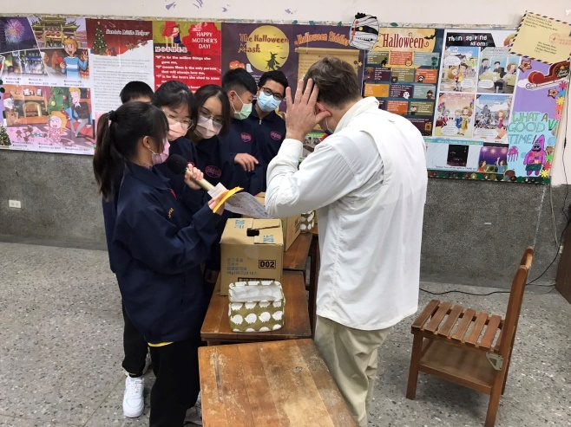
第一步驟:抽年級題目 |  | 第二步驟:大聲唸出題目並回答問題
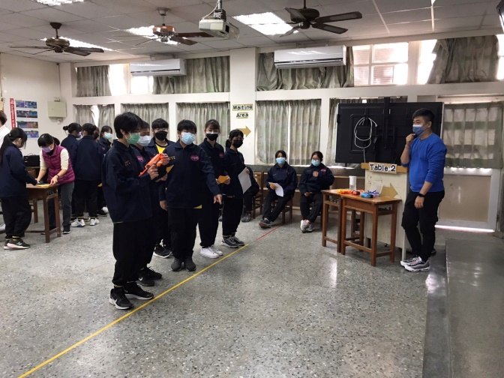 |  | 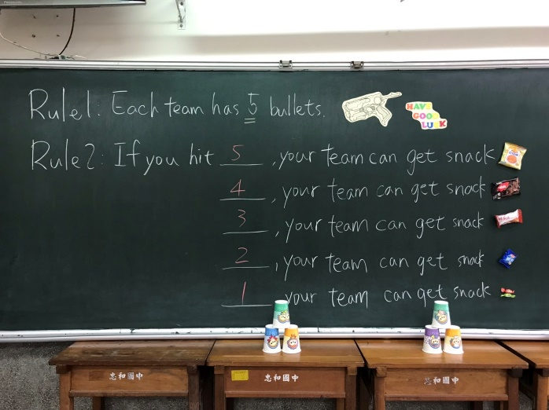
第三步驟:成功回答問題後進入射擊區 |  | 第四步驟:按照射擊成果領取獎品

