嘉義縣六腳鄉灣內國民小學
111學年度雙語國家政策－口說英語展能樂學計畫
國民中小學英語日活動成果報告表
活動名稱 | Santa Casey is coming |  | 辦理日期 | 111.12.19
辦理地點 | 灣內國小(禮堂/圖書室) |  | 參加人數 | 國小部共計61人
成果摘要-活動內容介紹及特色說明  (列點說明) | 1.一二年級(唱跳): Santa Claus is Coming to Town  - Action songs  2.三四年級(翻牌遊戲): Memory Card Game  - Each class will be divided into 2 groups  - Each time only one person could go up to the front and turn over 2 cards  - If the 2 cards match, the cards stay face up, otherwise face down  - The fastest group who makes all the cards turn over wins!  3.五六年級(聖誕彩蛋): Christmas Treasure Hunt  - Christmas Treasure Hunt  - 4/5 people in a group  - Goal: Help Santa find what he needs  - Procedure: Each group will be given 4 question cards and to find the tools that Santa need. Hints will only be provided after completing the tasks (the tasks are basically having a conversation with Casey or Fiona). The fastest to find all the tool cards and complete the worksheet will be the winner!
檢討或建議事項
照片說明（4-10張）
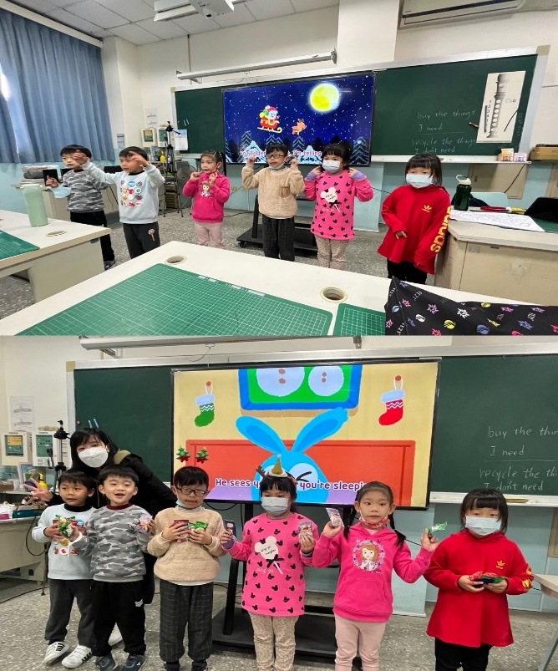 |  | 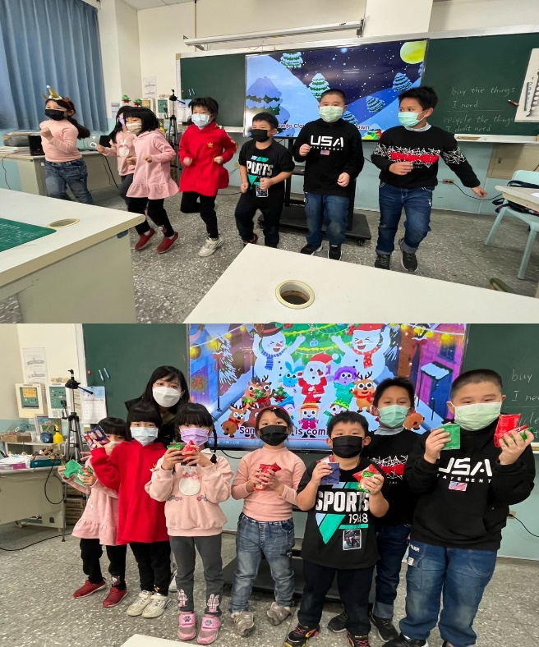
一二年級隨著外師一起聖誕節音樂律動。 |  | 一二年級隨著外師一起聖誕節音樂律動。
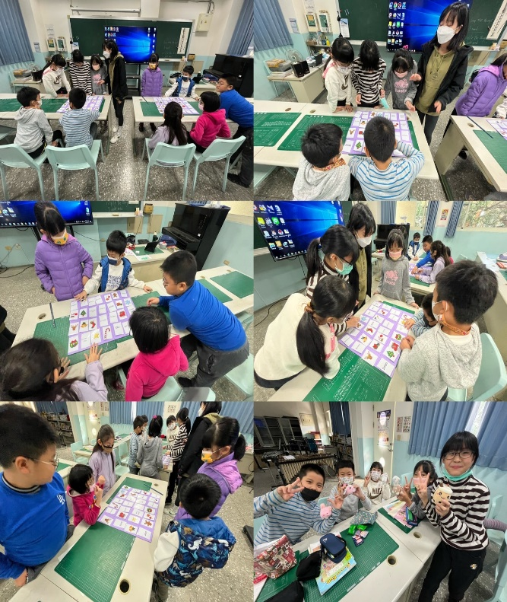 |  | 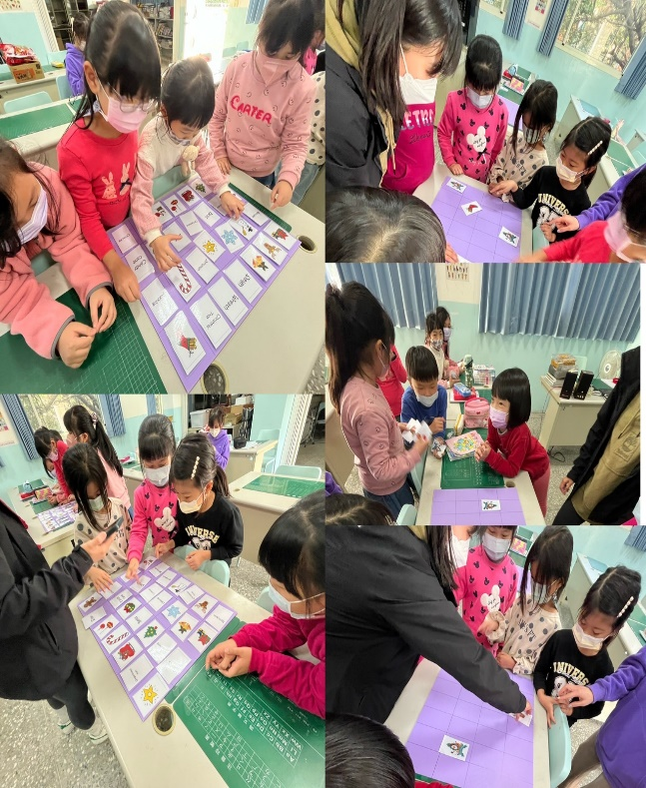
三四年級憑藉過人的記憶力，藉由團隊力量，成功配對一張張的聖誕節卡片。 |  | 三四年級憑藉過人的記憶力，藉由團隊力量，成功配對一張張的聖誕節卡片。
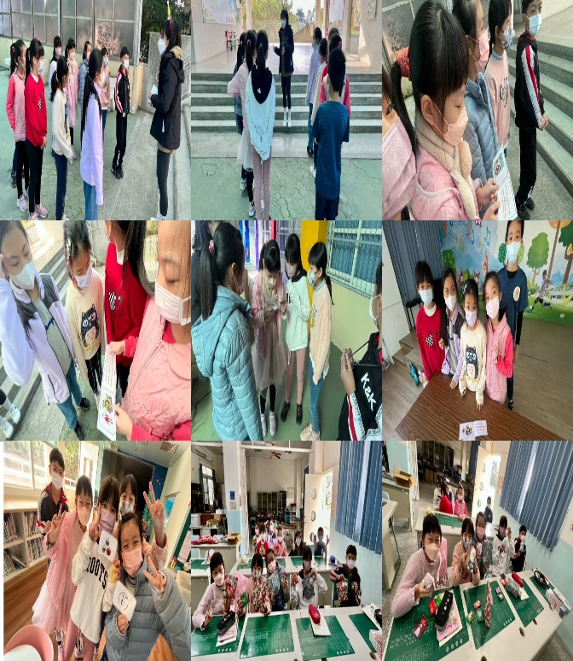 |  | 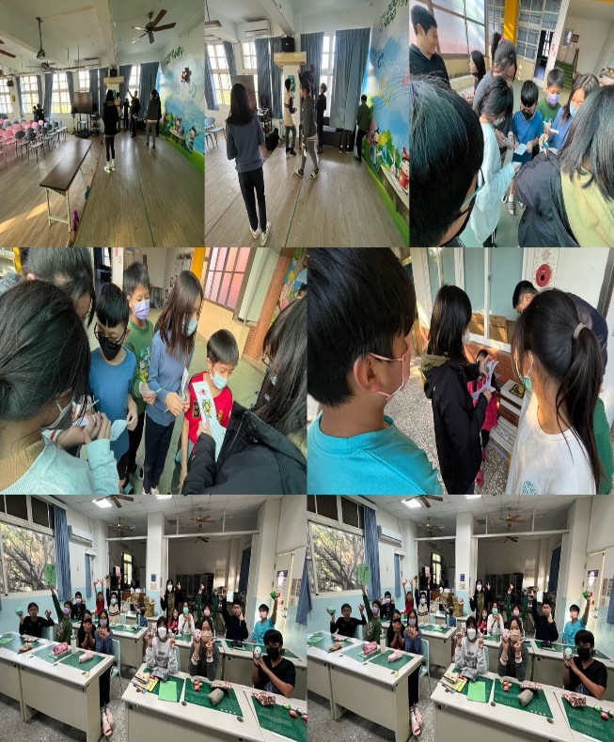
五六年級依照外師提示，分組到學校禮堂跟圖書室尋找聖誕節彩蛋，好不刺激。 |  | 五六年級依照外師提示，分組到學校禮堂跟圖書室尋找聖誕節彩蛋，好不刺激。

