嘉義縣民雄鄉國民小學
111學年度雙語國家政策－口說英語展能樂學計畫
國民中小學英語日活動成果報告表
活動名稱 | A Winter Party |  | 辦理日期 | 111.12.23
辦理地點 | Campus |  | 參加人數 | All the students and some of their parents, the faculty
成果摘要-活動內容介紹及特色說明  (列點說明) | Winter, especially December is the perfect time for parties.  At the forecourt of the school, Winter Party started with kids sang “We wish you a Merry Christmas” together, following by the wishing card (in English) exchange, and then time of gifting.  Students ordered a list of English songs to share, which are broadcast to the campus.  The party then went on with a series of activities, such as Sing and Dance challenge, online Winter Wish Challenge, etc.  Students went home that day with the gifts and the prizes of the challenges and satisfying smiles on their faces.
檢討或建議事項 | - Timing: The time needed for each challenge game should be equivalent.  - The schcedule: The Gifting and Singing could be moved to the end of the party, which would be a perfect ending of the activity.
照片說明（4-10張）
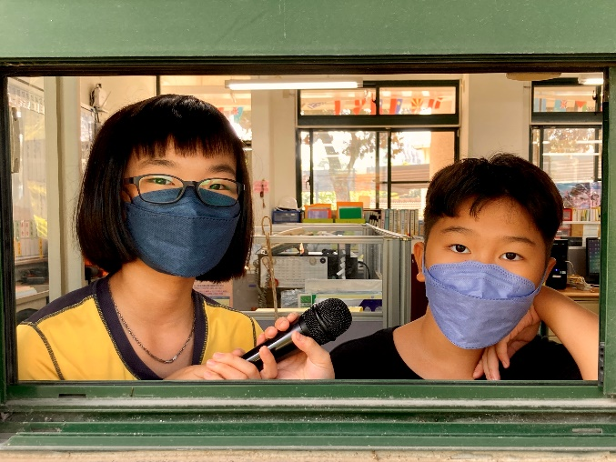 |  | 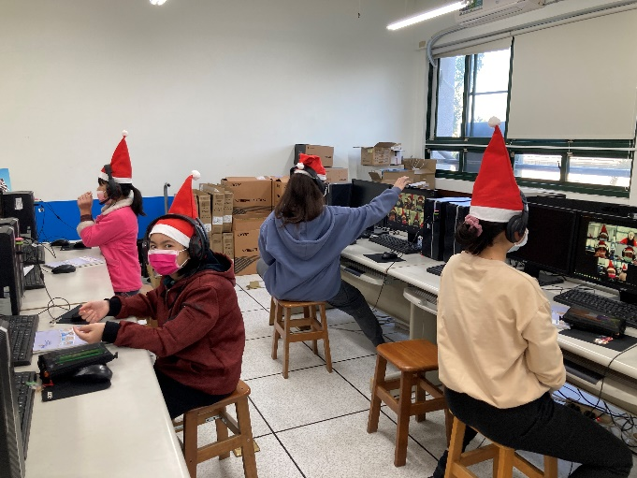
DJs of the English Song Broadcast |  | Online Winter Wish callenge
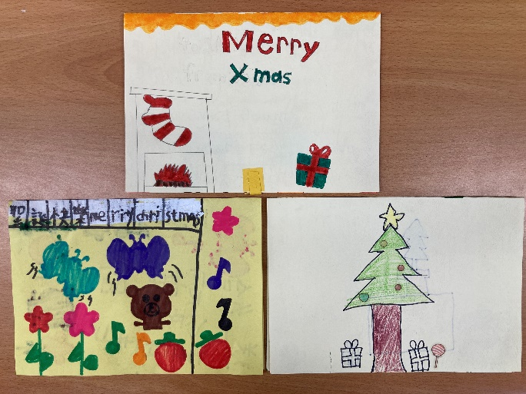 |  | 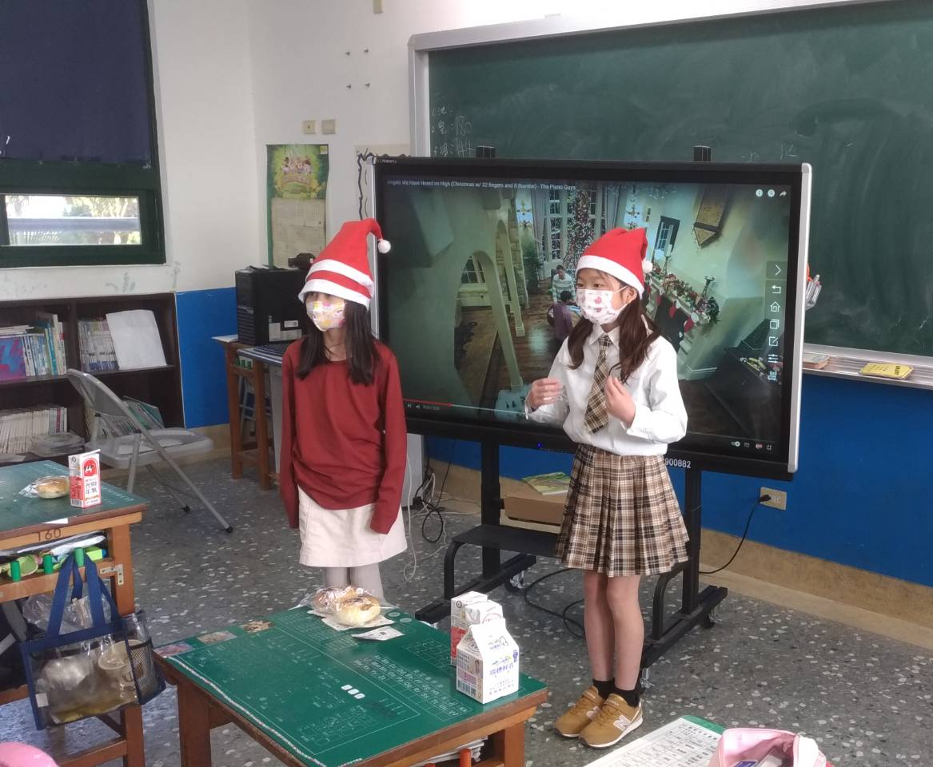
Wishing Card Exchange |  | Singing and Dancing Challenge
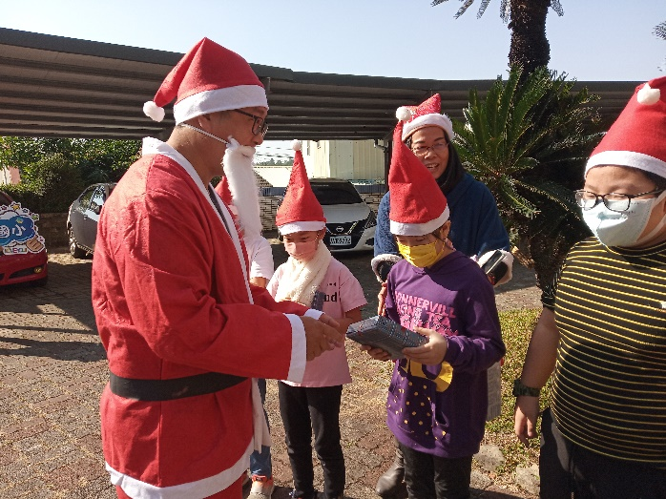 |  | 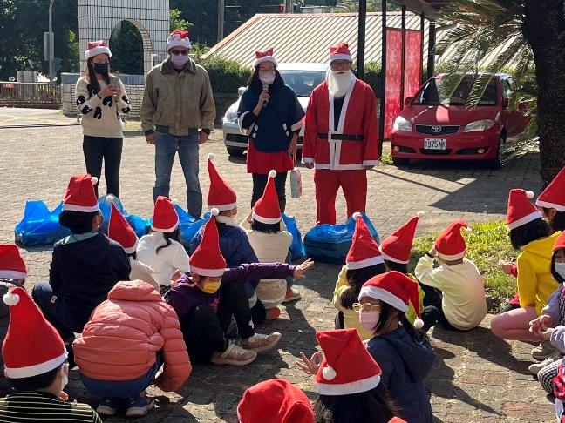
Gifting time |  | Singing “We wish you a merry Christmas” to gether
(表格不夠，請自行增列）

