嘉義縣鹿草國民中學
111學年度雙語國家政策－口說英語展能樂學計畫
國民中小學英語日活動成果報告表
活動名稱 | English Skit Day |  | 辦理日期 | 111.12.12
辦理地點 | Activity Center |  | 參加人數 | 158
成果摘要-活動內容介紹及特色說明  (列點說明) | Title: English Skit Day  The activity, English Skit Day, aimed for creating English speaking opportunities for students. Students acted out the dialogue the had learned from the English classes. They interpreted the dialogue in the books in their own ways and performed in groups on the stage.  The topic of the dialogues are as follows:  7th grade: My Friend Is Showing Me Around  8th grade: How Do We Go to the Hotel?  9th grade: The Amazing Candy That Cleans Your Teeth
檢討或建議事項 | Everything went very well if not went beyond our expectation. There was nothing to improve, and actually I think this is one of the best ways to train students’ speaking proficiency.
照片說明（4-10張）
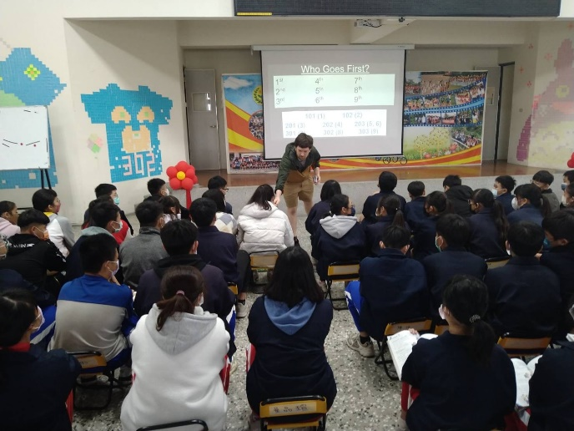
外師與學生全英語場邊互動 |  | 101班表演
 |  | 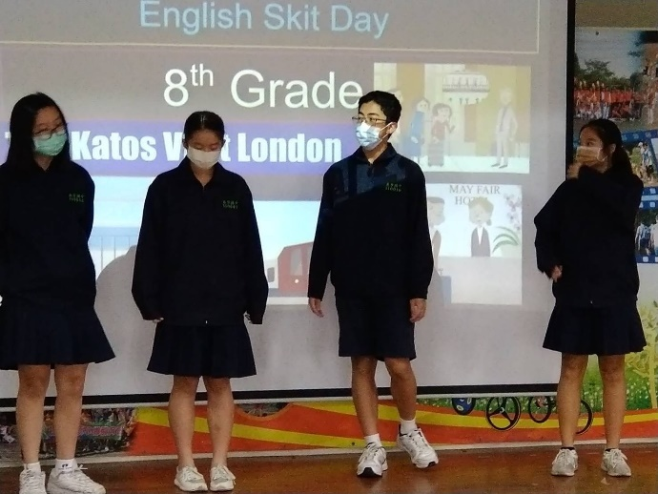
102班表演 |  | 201班表演
202班表演 |  | 203班表演
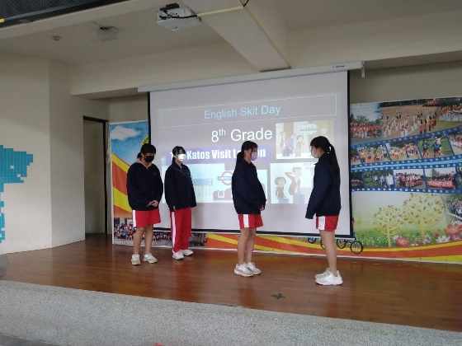
203班表演 |  | 301英語分組班表演
302英語分組班表演 |  | 303英語分組班表演

